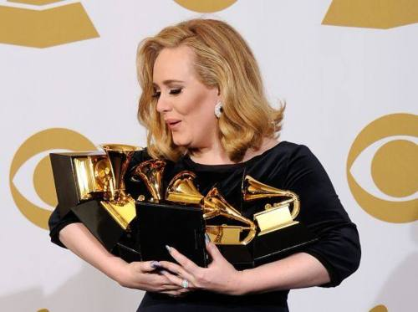
Performer: ____________ ; Year: _______________; Genre: ____________

I let it fall, my heart,
And as it fell, you rose to _______________ it, A) Blank instead of a word
It was dark and I was _______________, ____________________
Until you kissed my lips and you saved me,
My hands, they were _______________, but my knees were far too weak,
To stand in your arms without falling to your ________________,
[Bridge] B) Choice
But there's a ________ to you that I never knew, never knew, tide/side/part
All the _________ you'd say, they were never true, never true, things/lies/stories
And the games you'd play, you would always win, always win,
[Chorus] C) Rhyme
But I set fire to the ________, vain
Watched it _________ as I touched your face, swore
Well, it burned while I cried,
'Cause I heard it screaming out your _______, your _______, aim
When laying with you I could stay there, D) Synonyms
Close my eyes, feel you here ___________, always/infinitely
You and me together, ___________ is better, zero/naught
[Chorus]
I set fire to the rain, E) Word building
And I threw us into the ____________, inflame
Well, I felt something die,
'Cause I knew that that was the last ________, the last _________, alltimer
F) Mixed up letters
_______________ I wake up by the door, tmsmeieos
That heart you __________ must be waiting for you, gtacuh
Even now, when we're already over,
I can't help ______________ from looking for you, fyemsl
[Chorus]
Oh, no,
Let it burn, oh,
Let it burn,
Let it burn.

1. How many Grammys did the singer win at last year's ceremony?
2. What is the name of the singers debut album?
3. The singers said that her music hiatus will last ... (how long)?

